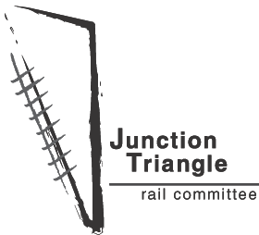
Electric Train Music Series
Sundays in July at 12:30 p.m. in the Junction Triangle

Acoustic performances:

Sunday, July 4
Campbell Park, Performer Adam Volpentesta
Sunday, July 11
Carlton Park, Performer Andrew Cash

Sunday, July 18
Erwin Krickhahn Park, Performer Mark Ripp

Help Drum Diesel Out of Town:

Sunday, July 25
Perth Square, Special Sunday Concert

Admission is free.

The Electric Train Music Series
is held in conjunction with the
Junction Triangle Picnics in the
Parks, 11 a.m. to 1 p.m. every
Sunday in July.

Residents and neighbours pack
a picnic lunch and a blanket and
enjoy the common space of the
Junction Triangle.

Presented by the Junction Triangle Rail Committee, Junctiontriangle.ca

